* **MySQL Database and Class Registration**

Stephanie Loper

The University of Arizona Global Campus

CST 499 Capstone for Computer Software Technology  
Instructor: Joseph Rangitsch

10.14.2024

**1. Screenshots of the Database and Tables**

* **Database Tables**
  + **tblUsers structure**
  + 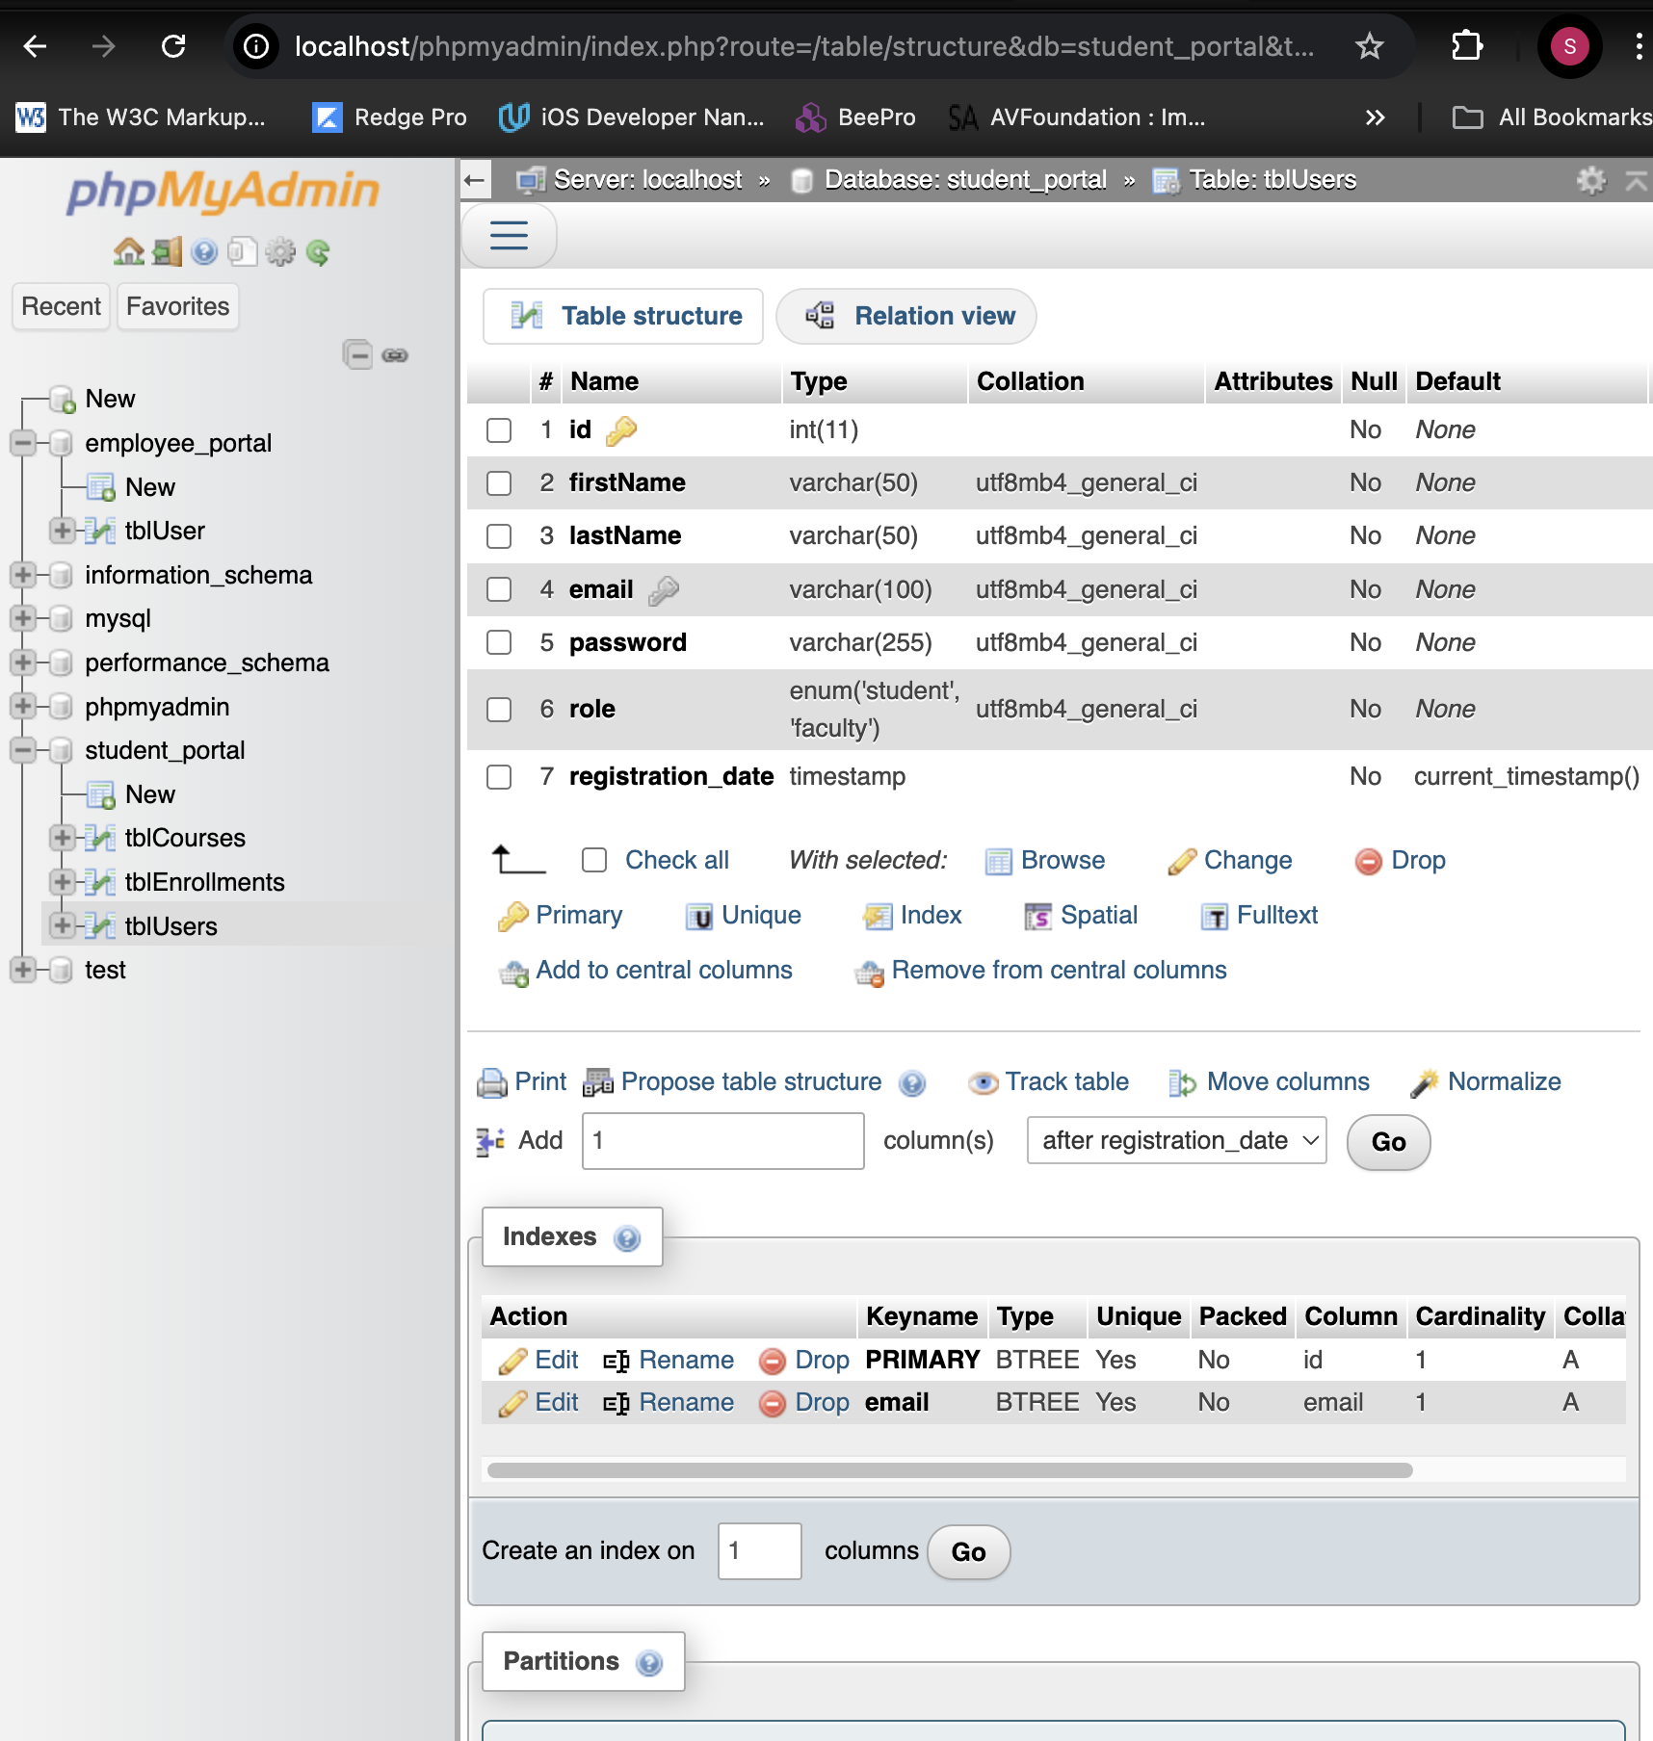
  + **tblCourses structure**
  + 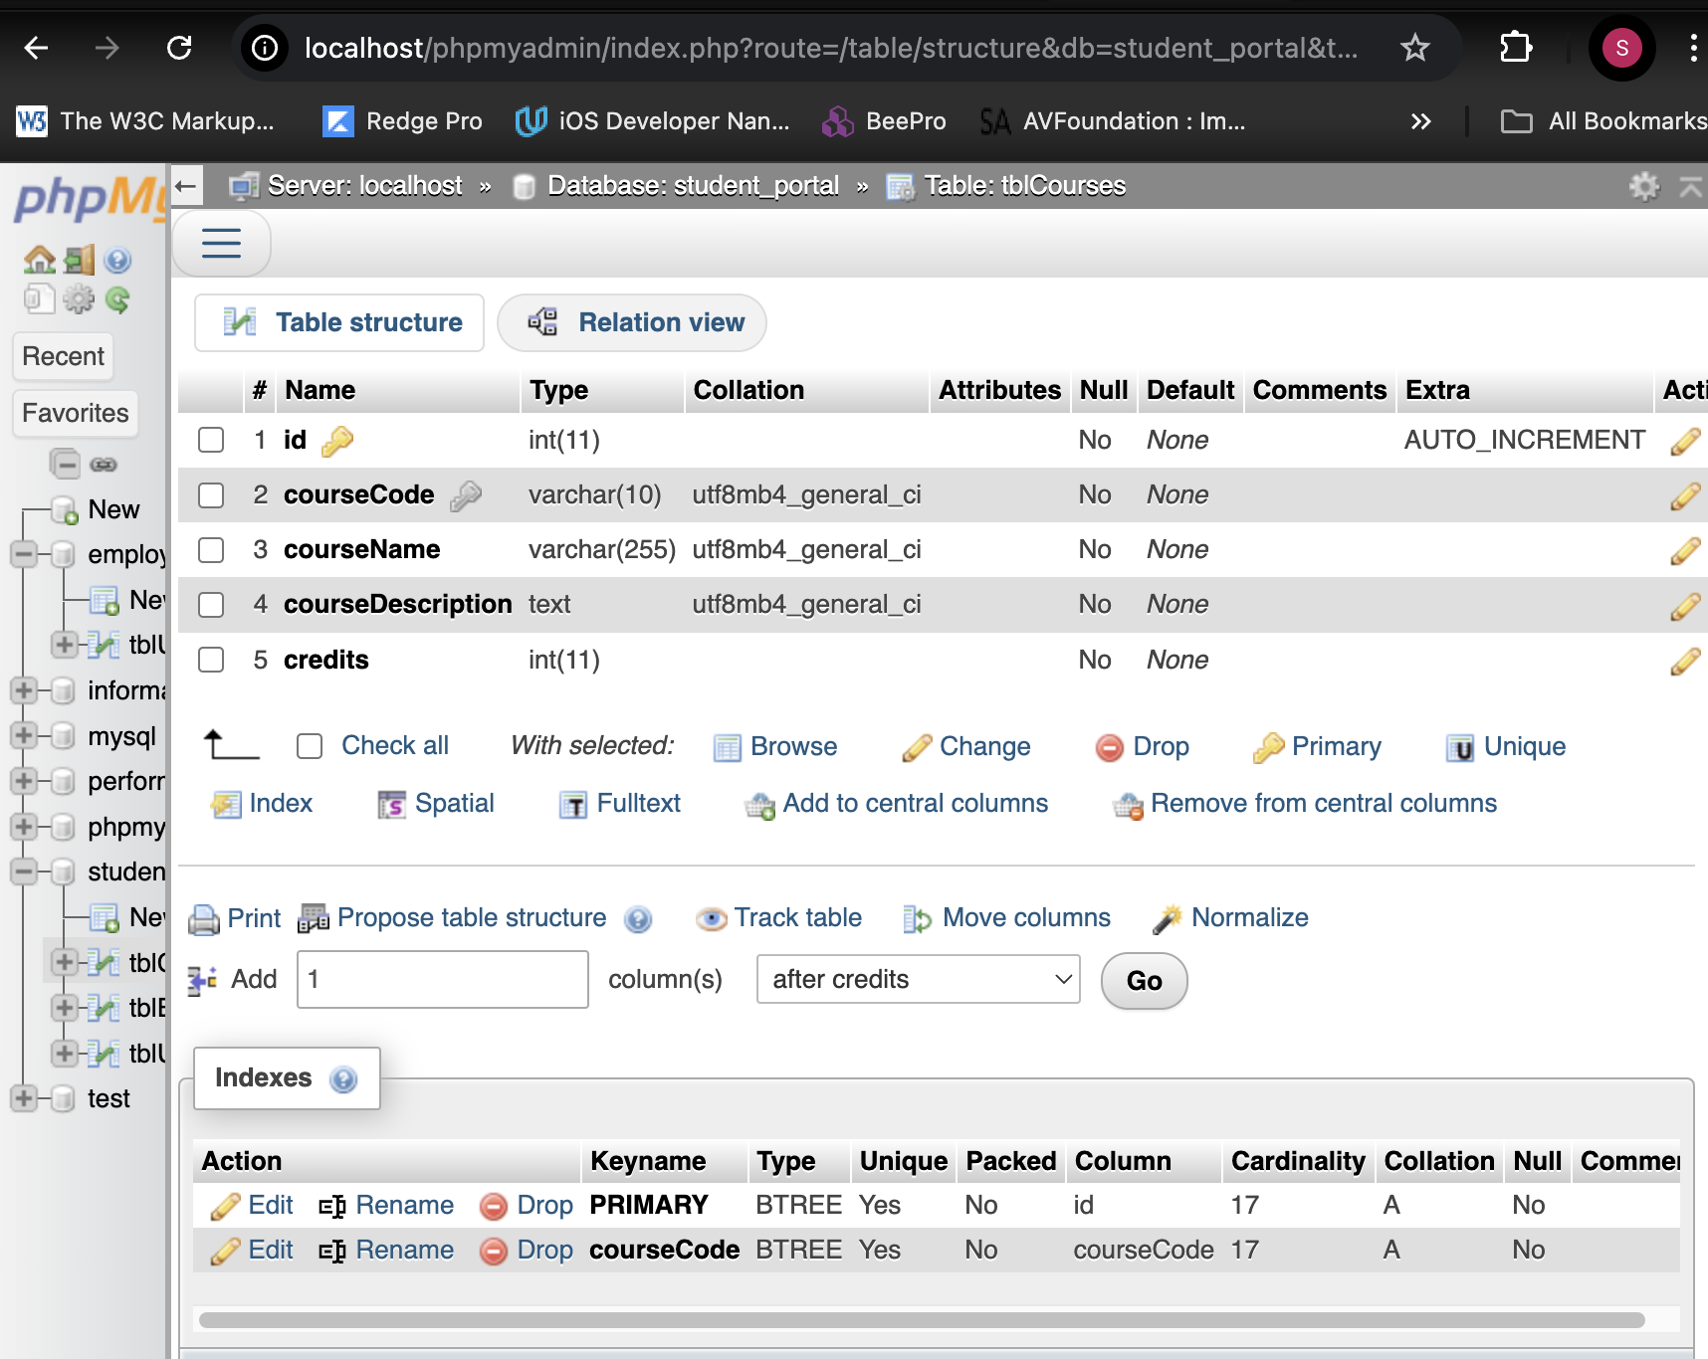
  + **tblEnrollments structure**
  + 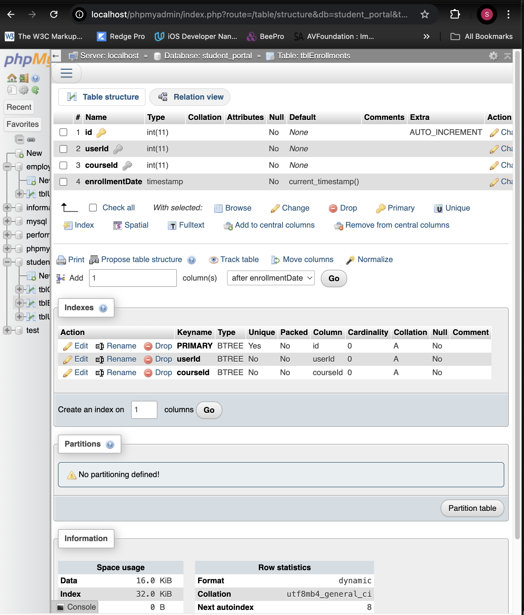

**2. Screenshots of Key Operations**

* **Before Course Registration (empty tblEnrollments)**
* 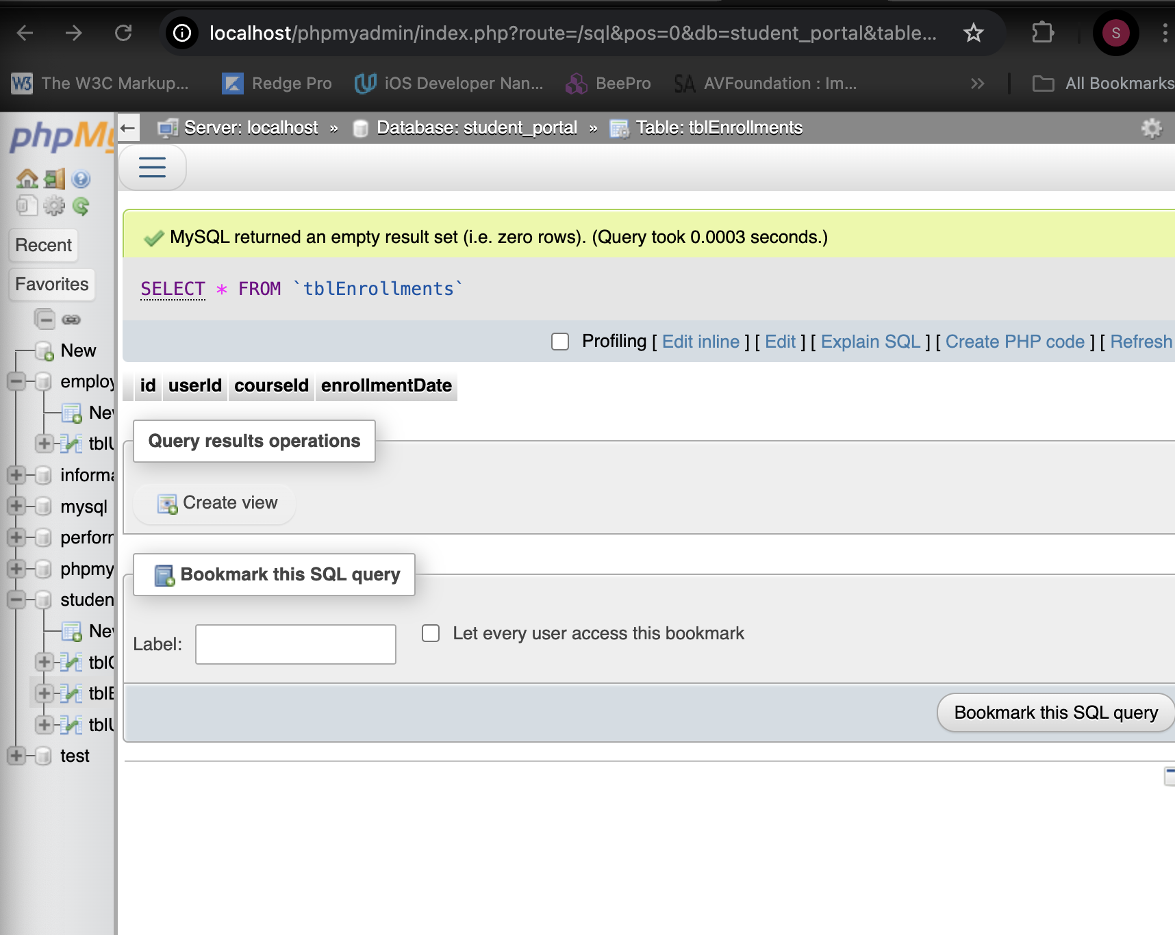
* **After Course Registration (populated tblEnrollments)**
* 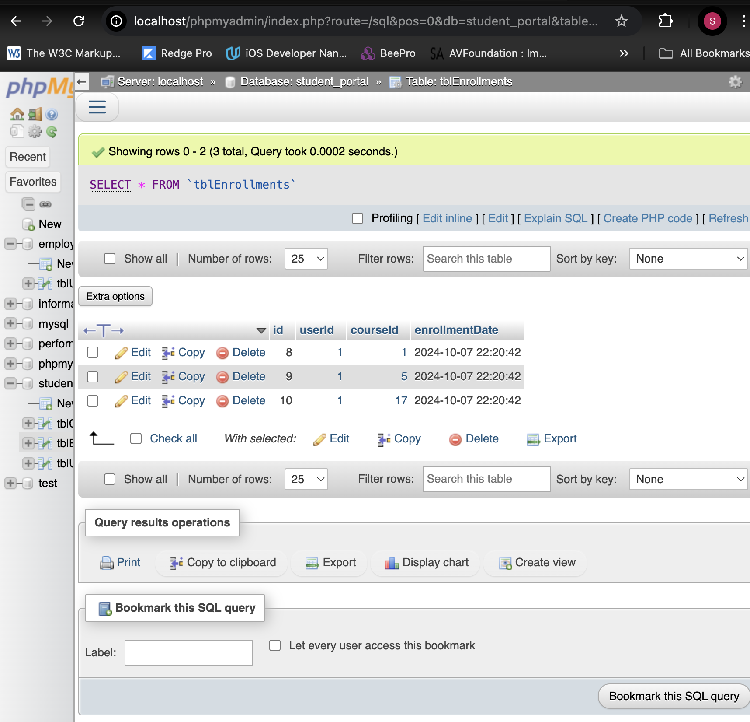
* **After Course Deletion (updated tblEnrollments)**
* 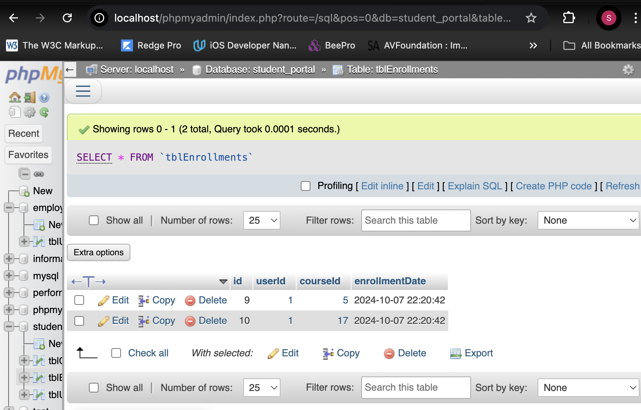

**3. Screenshots of the Pages Created**

* **Dashboard Page with Registered Courses**
* 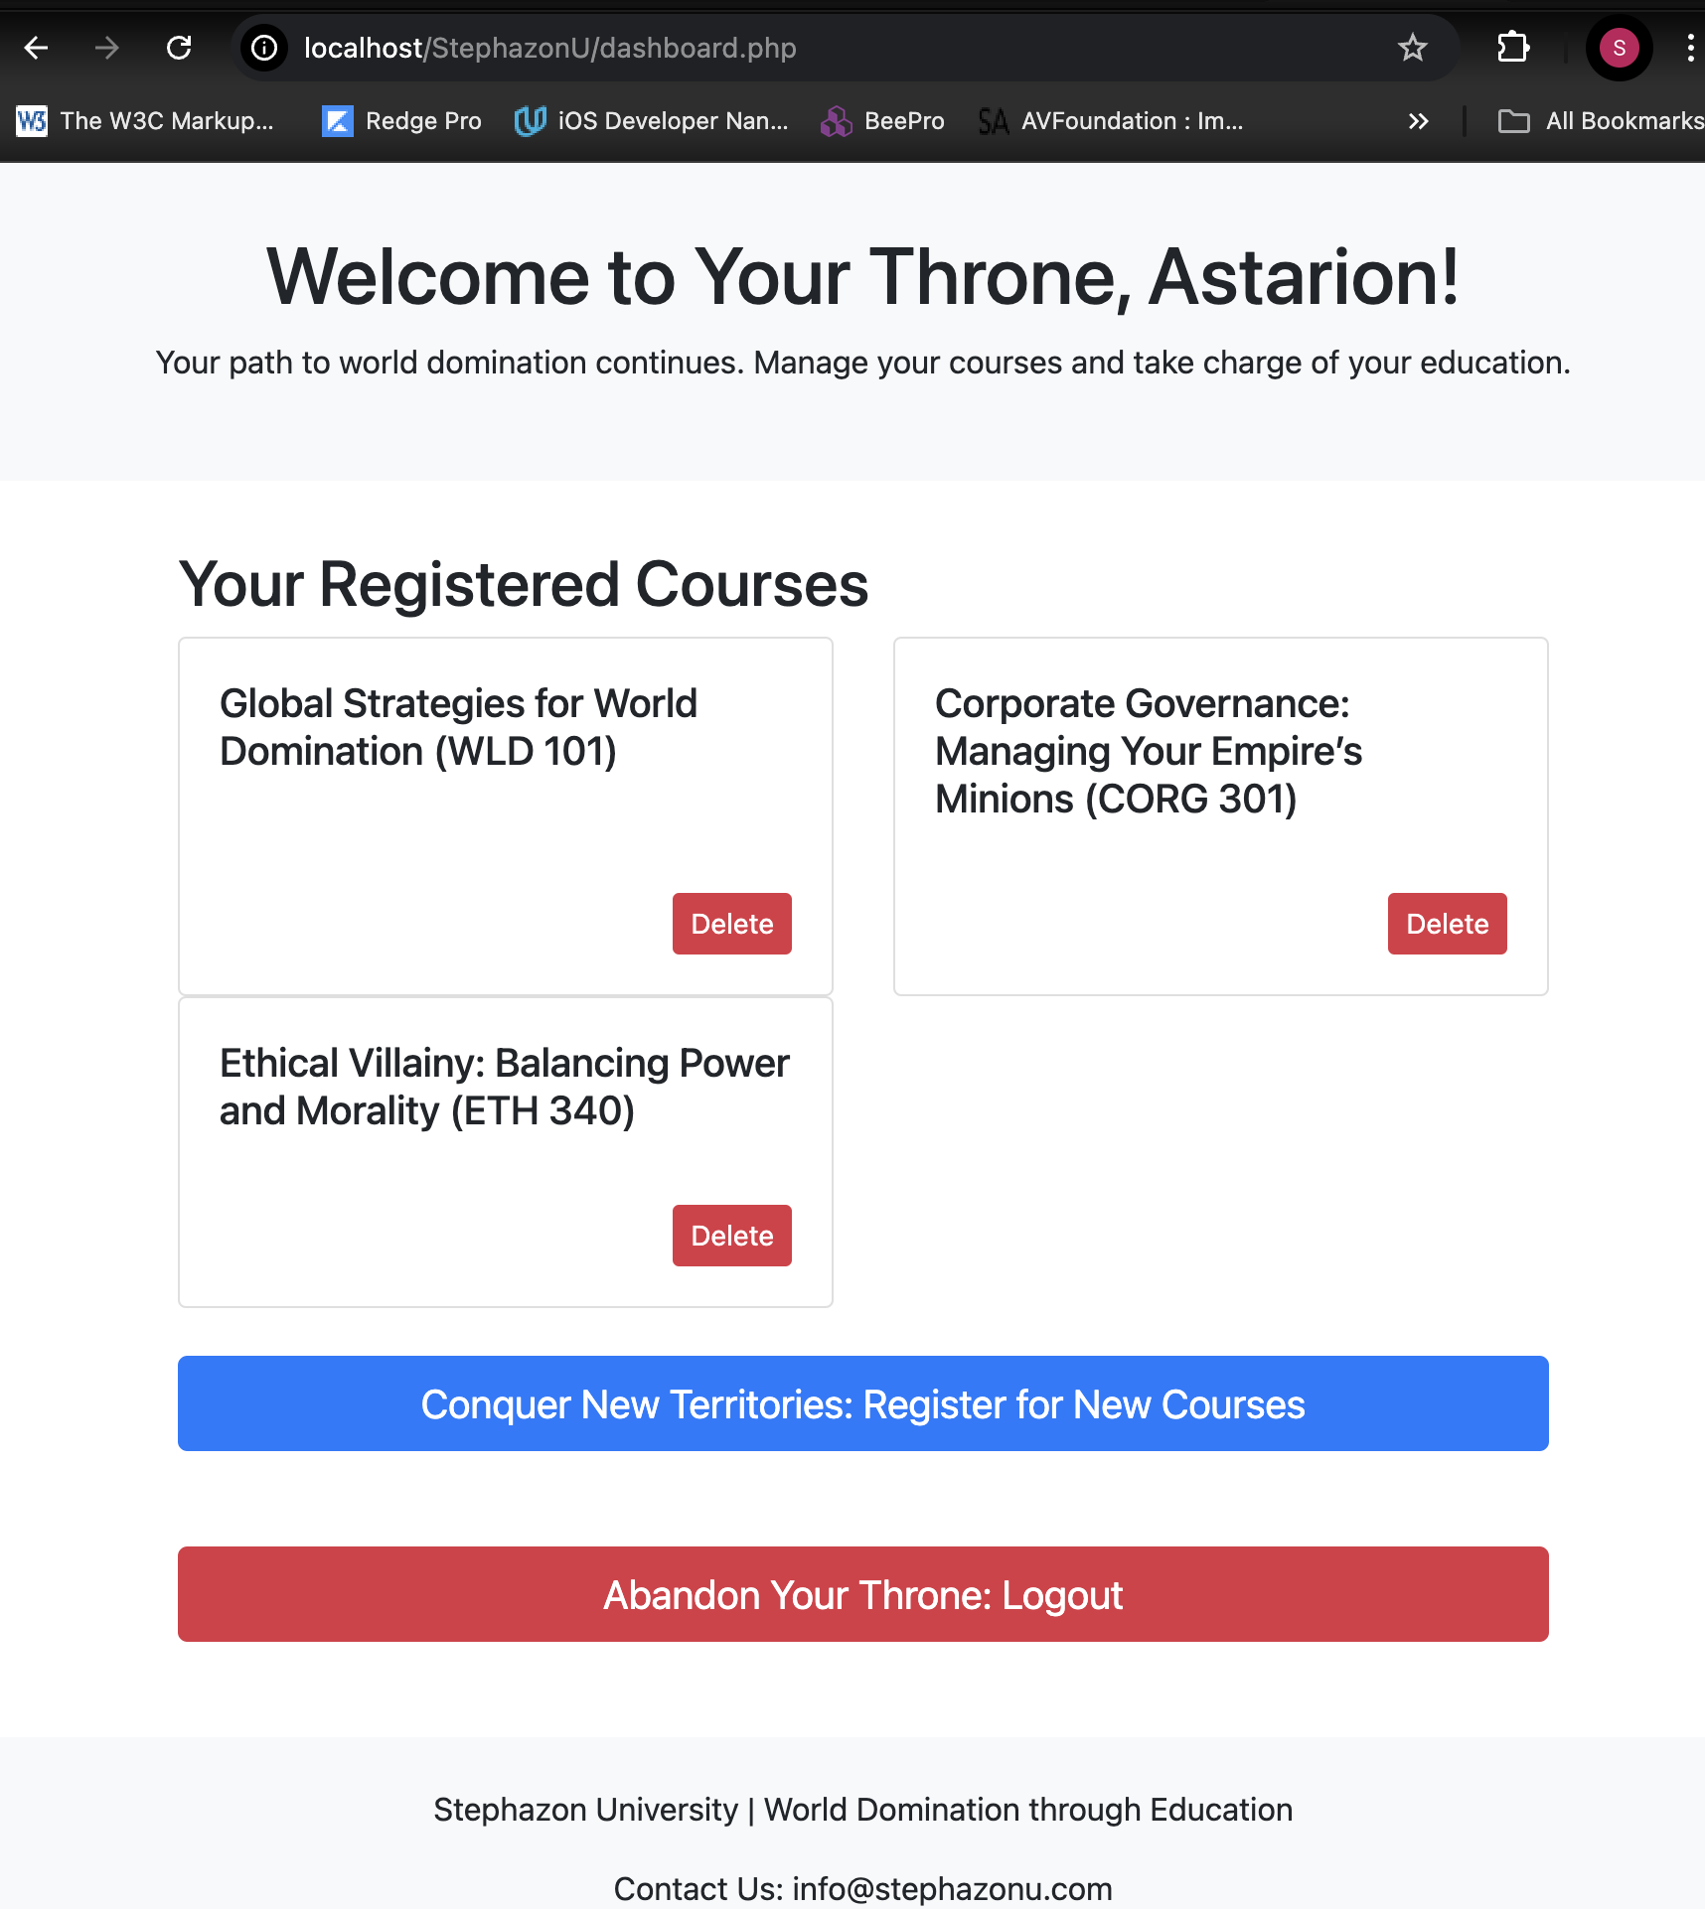
* **Register Courses Page**
* 
* **Successful Course Registration (Dashboard update)**
* 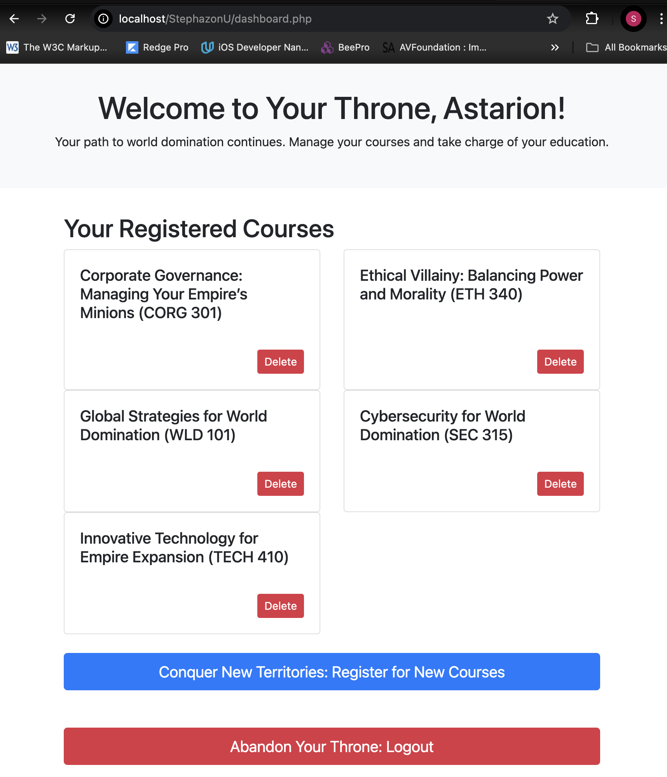
* **Before and After Course Deletion on Dashboard**
* 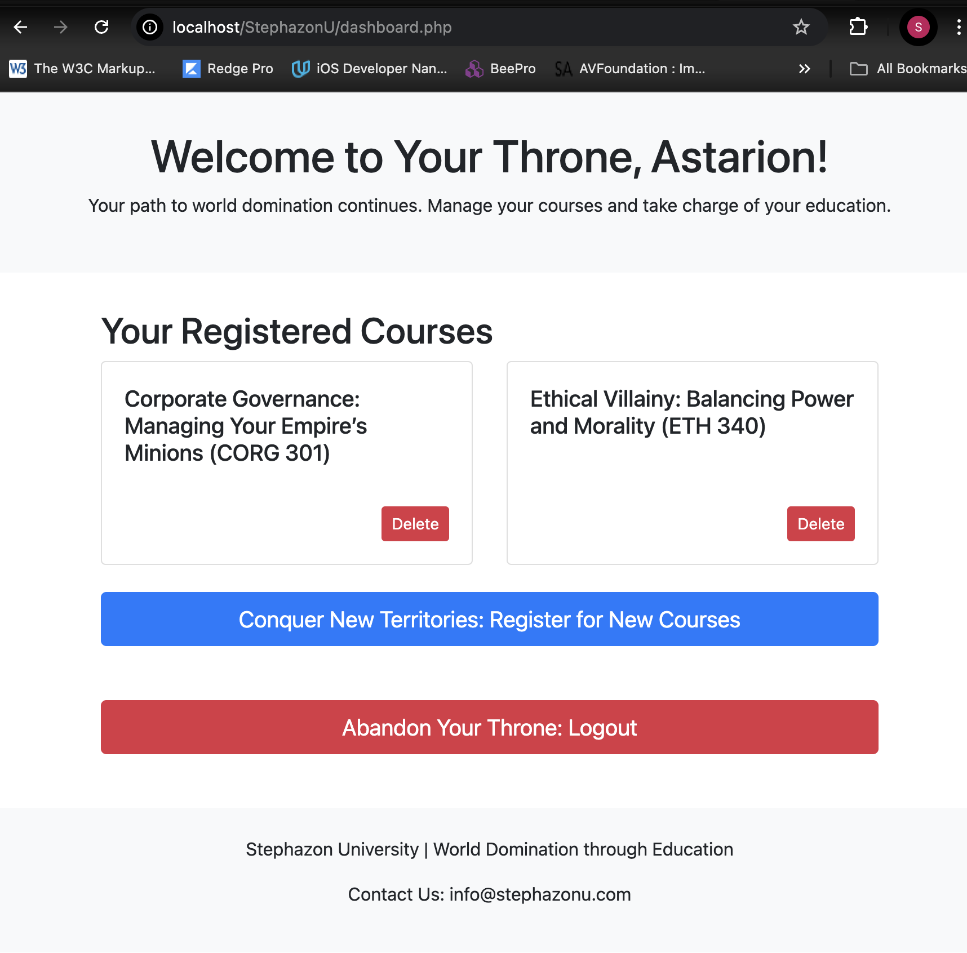
* **Login Page**
* 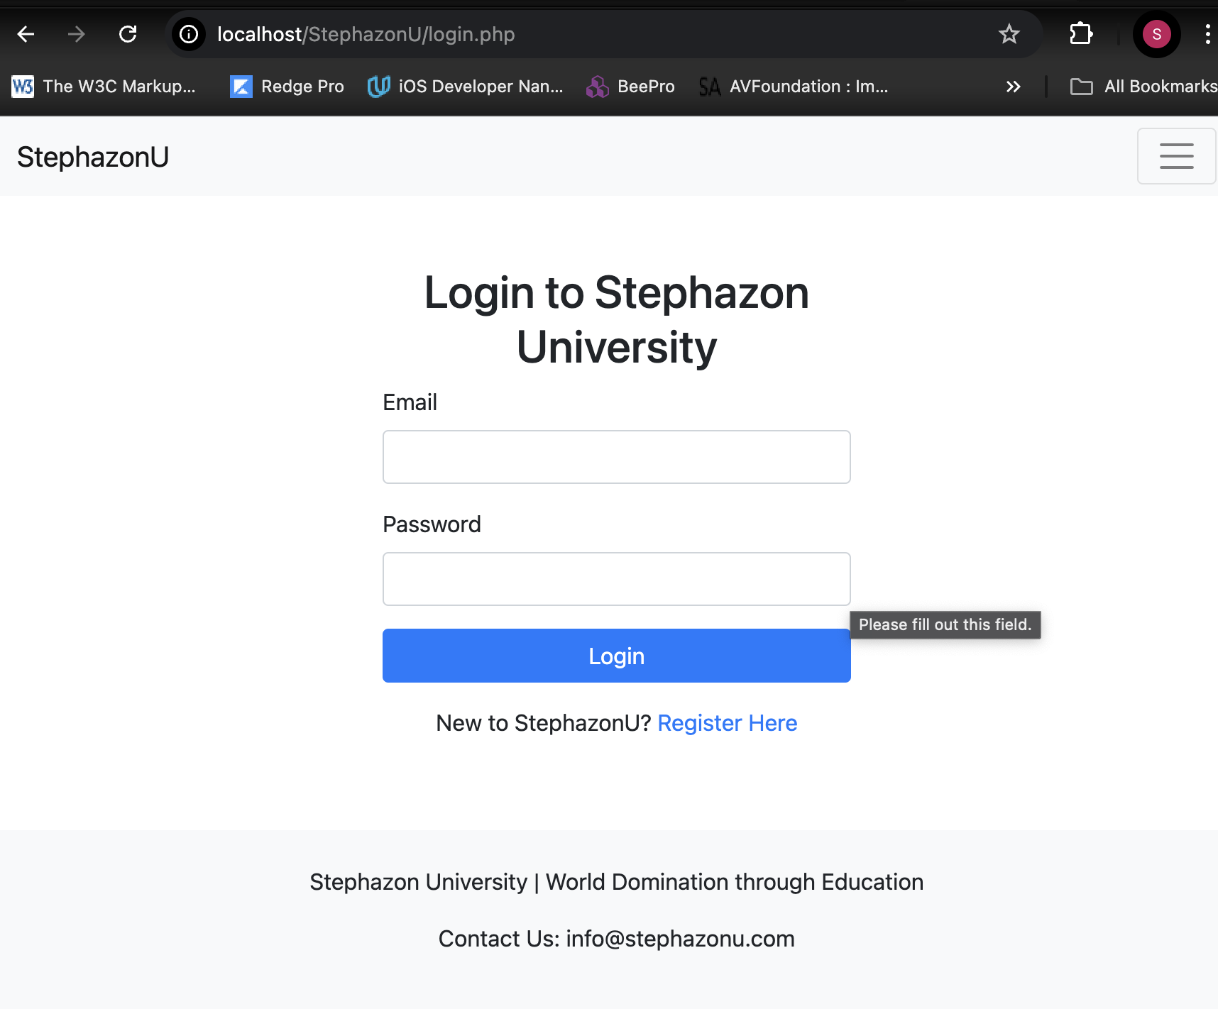
* **Registration Page**
* 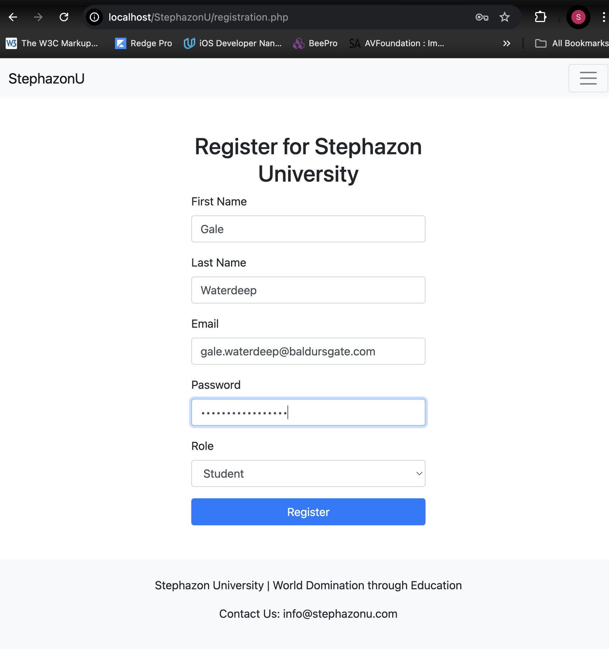
* 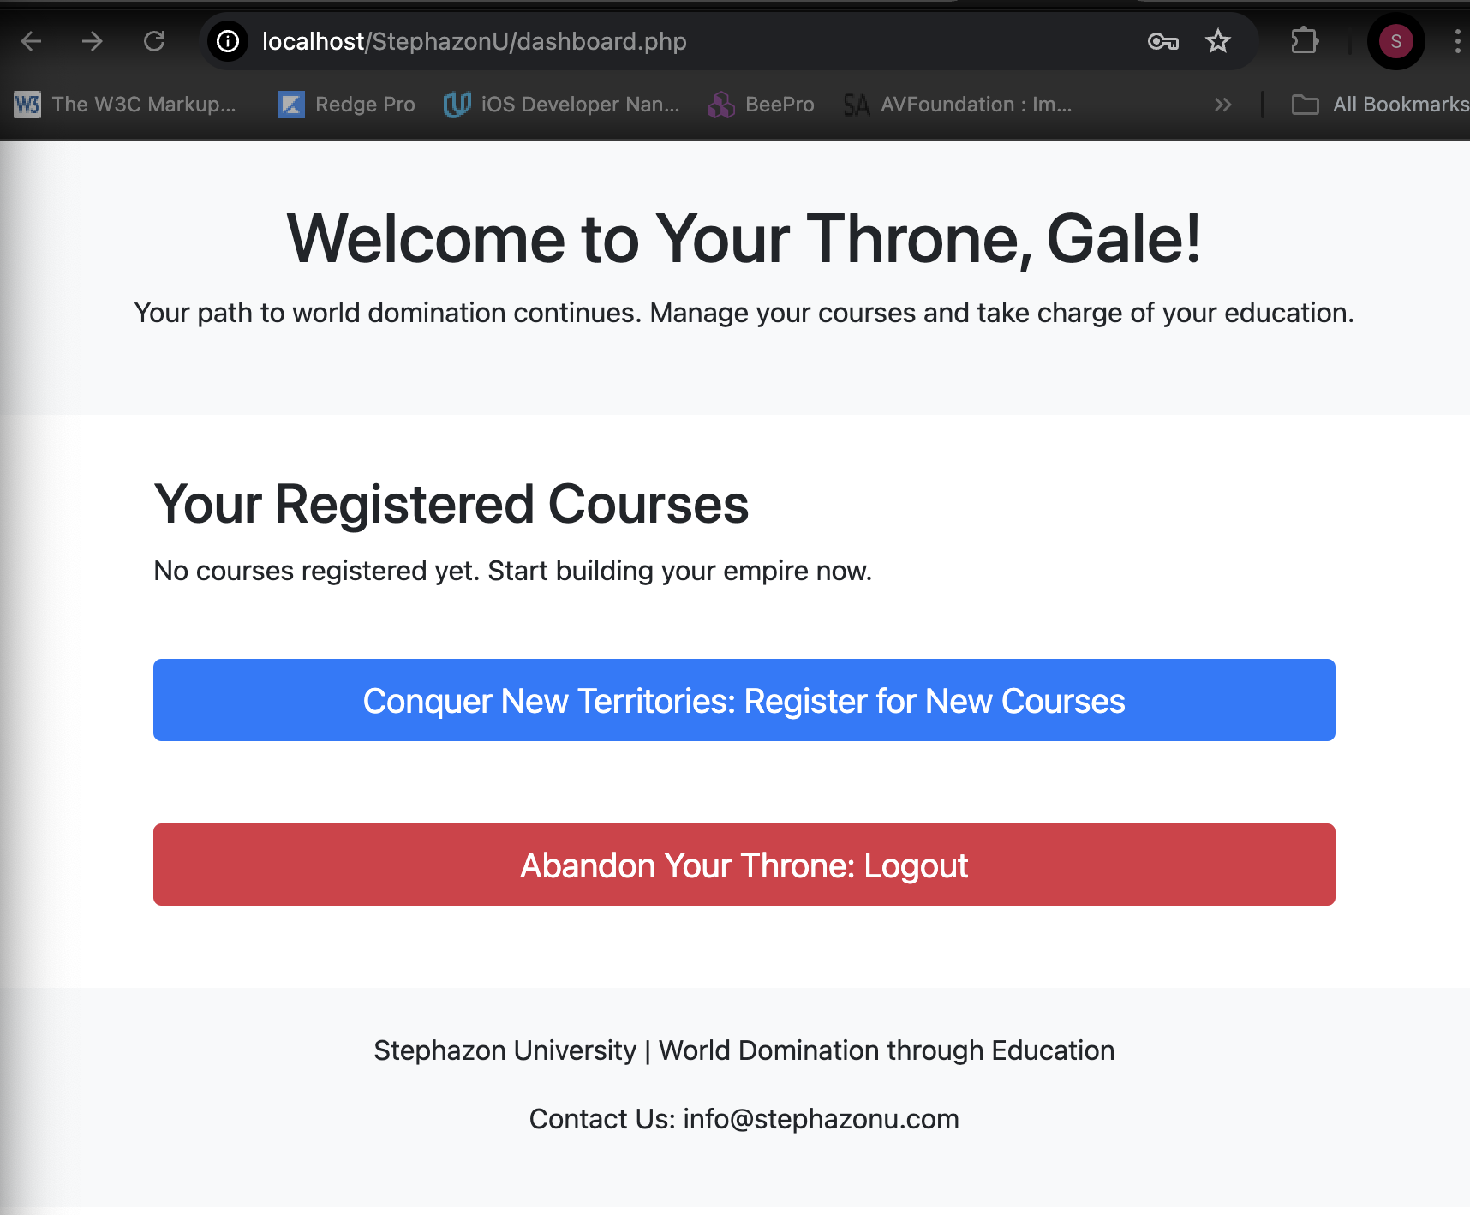

**4. Screenshots of the PHP Code**

* **Database Connection (db_connection.php)**
* 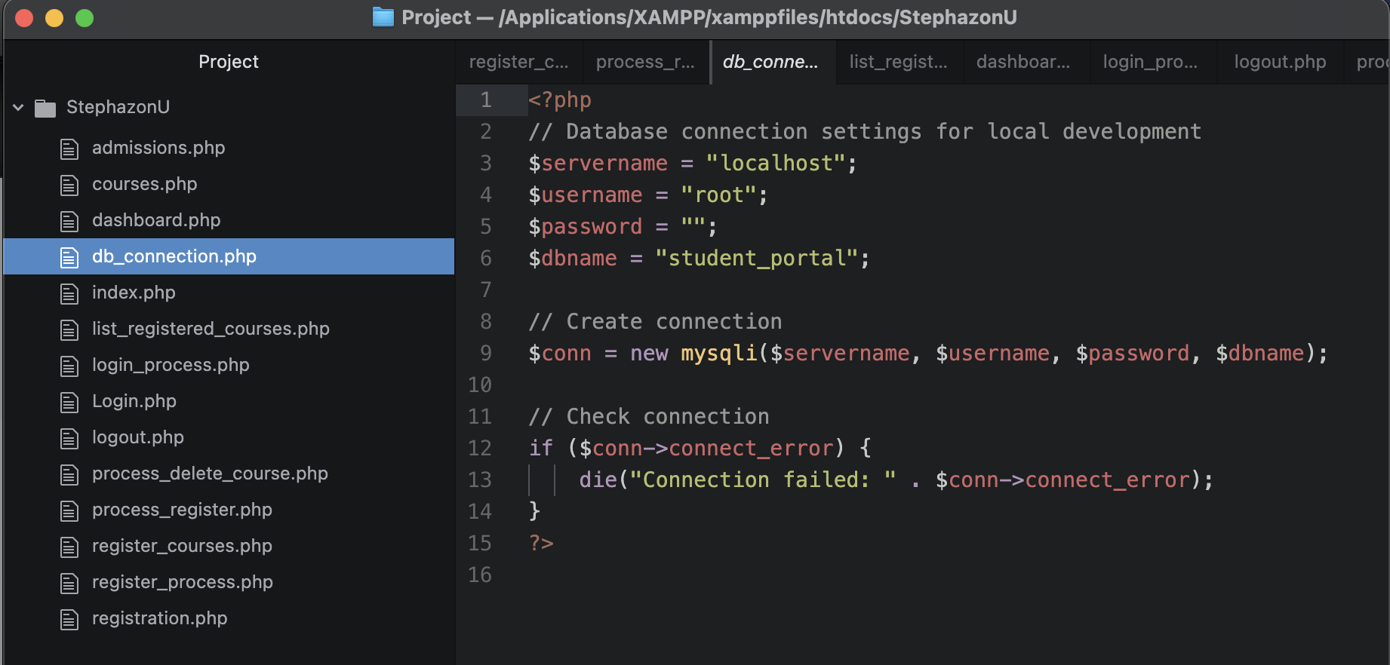
* **Login Process (login_process.php and login.php)**
* 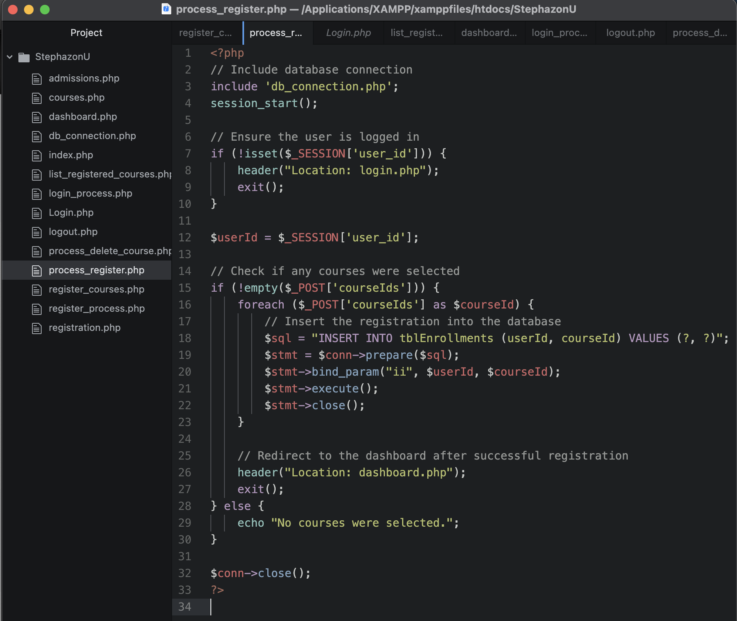
* 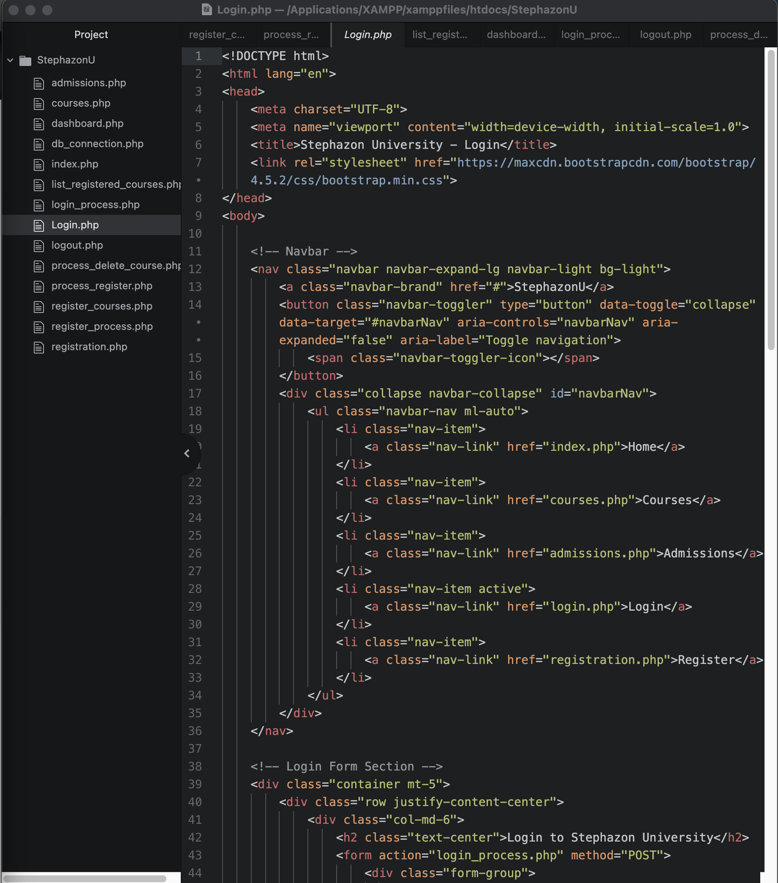
* 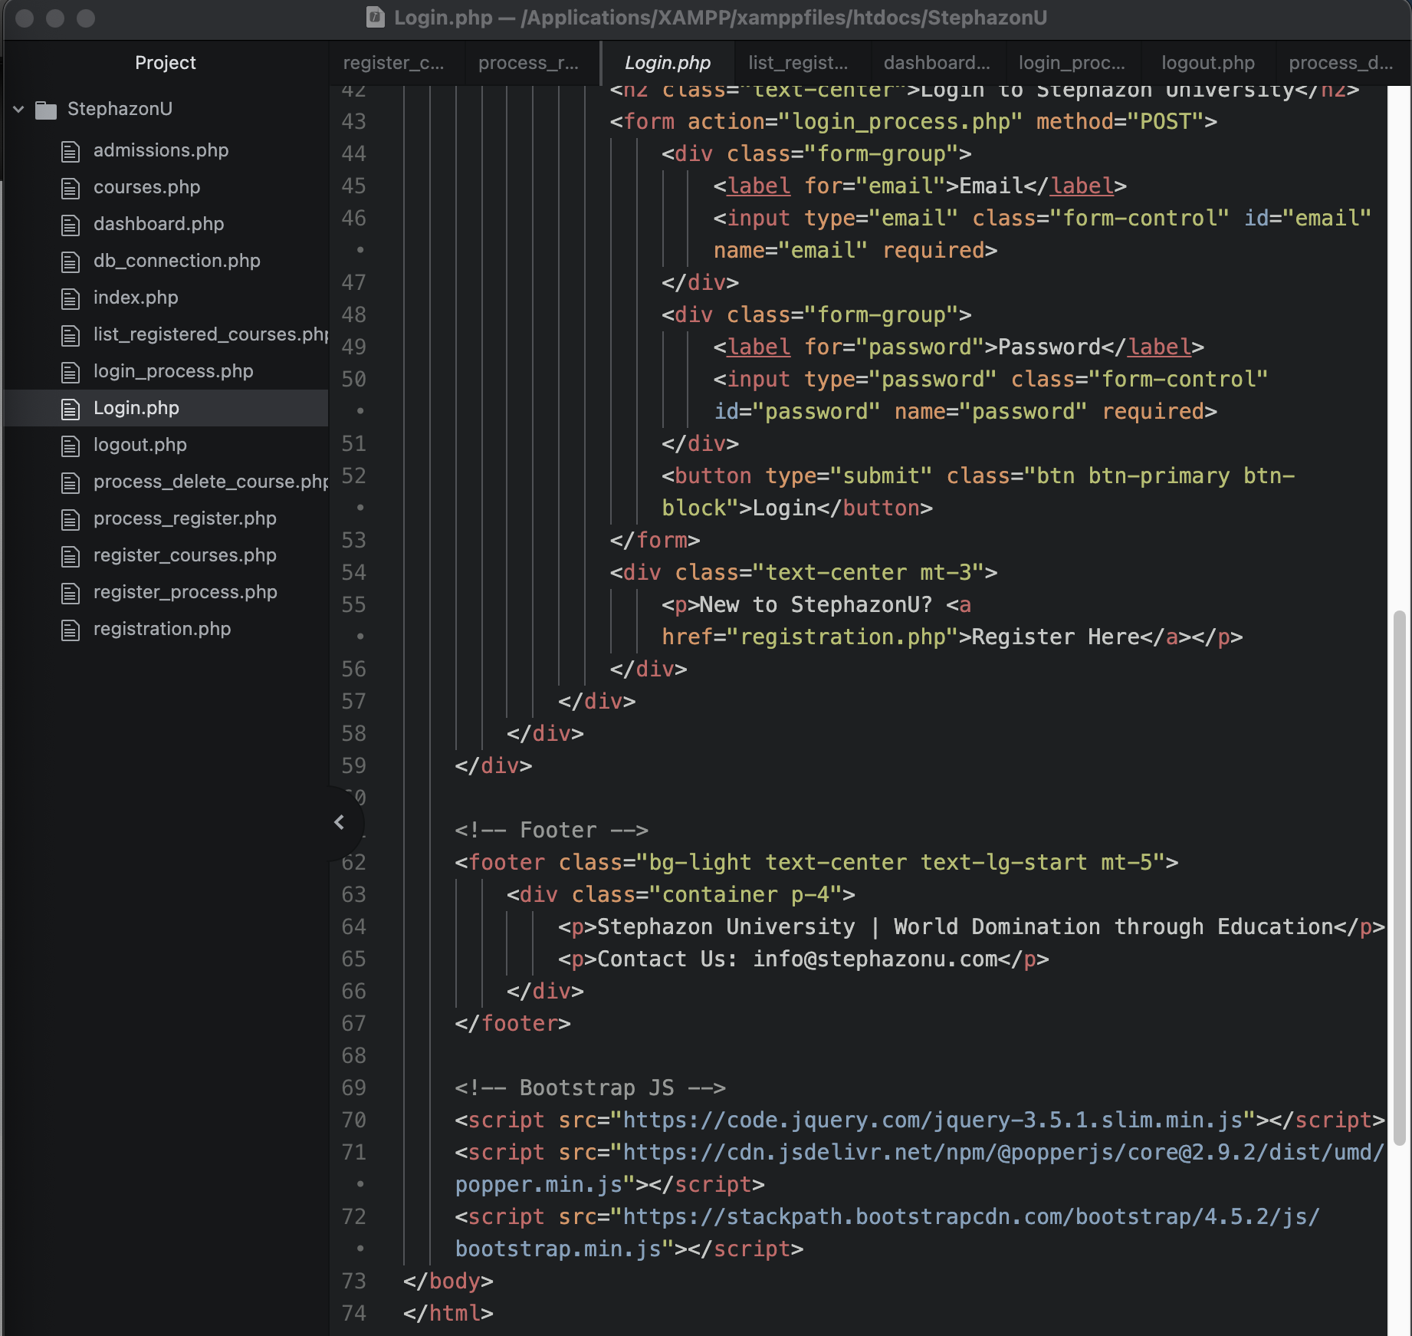
* **Register Courses Logic (register_courses.php and process_register.php)**
* 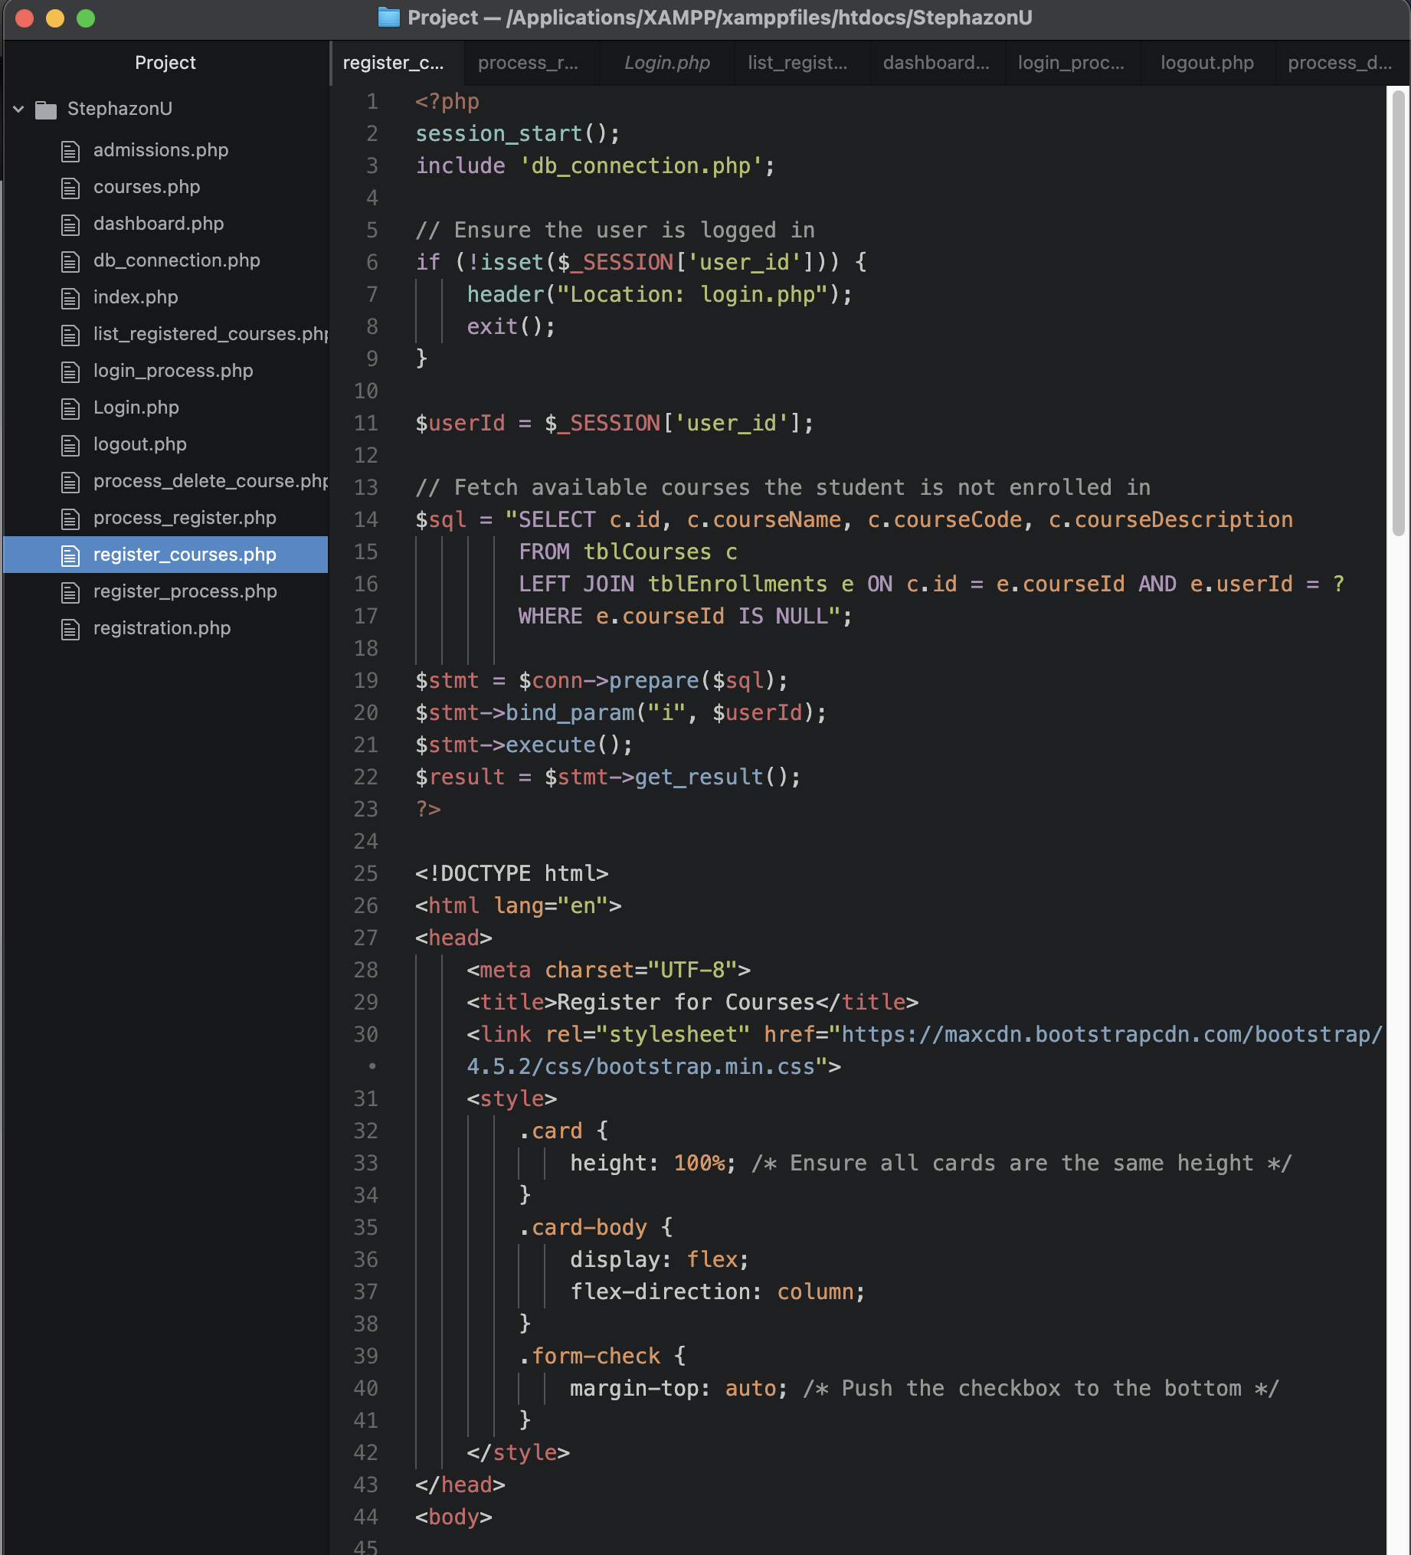
* 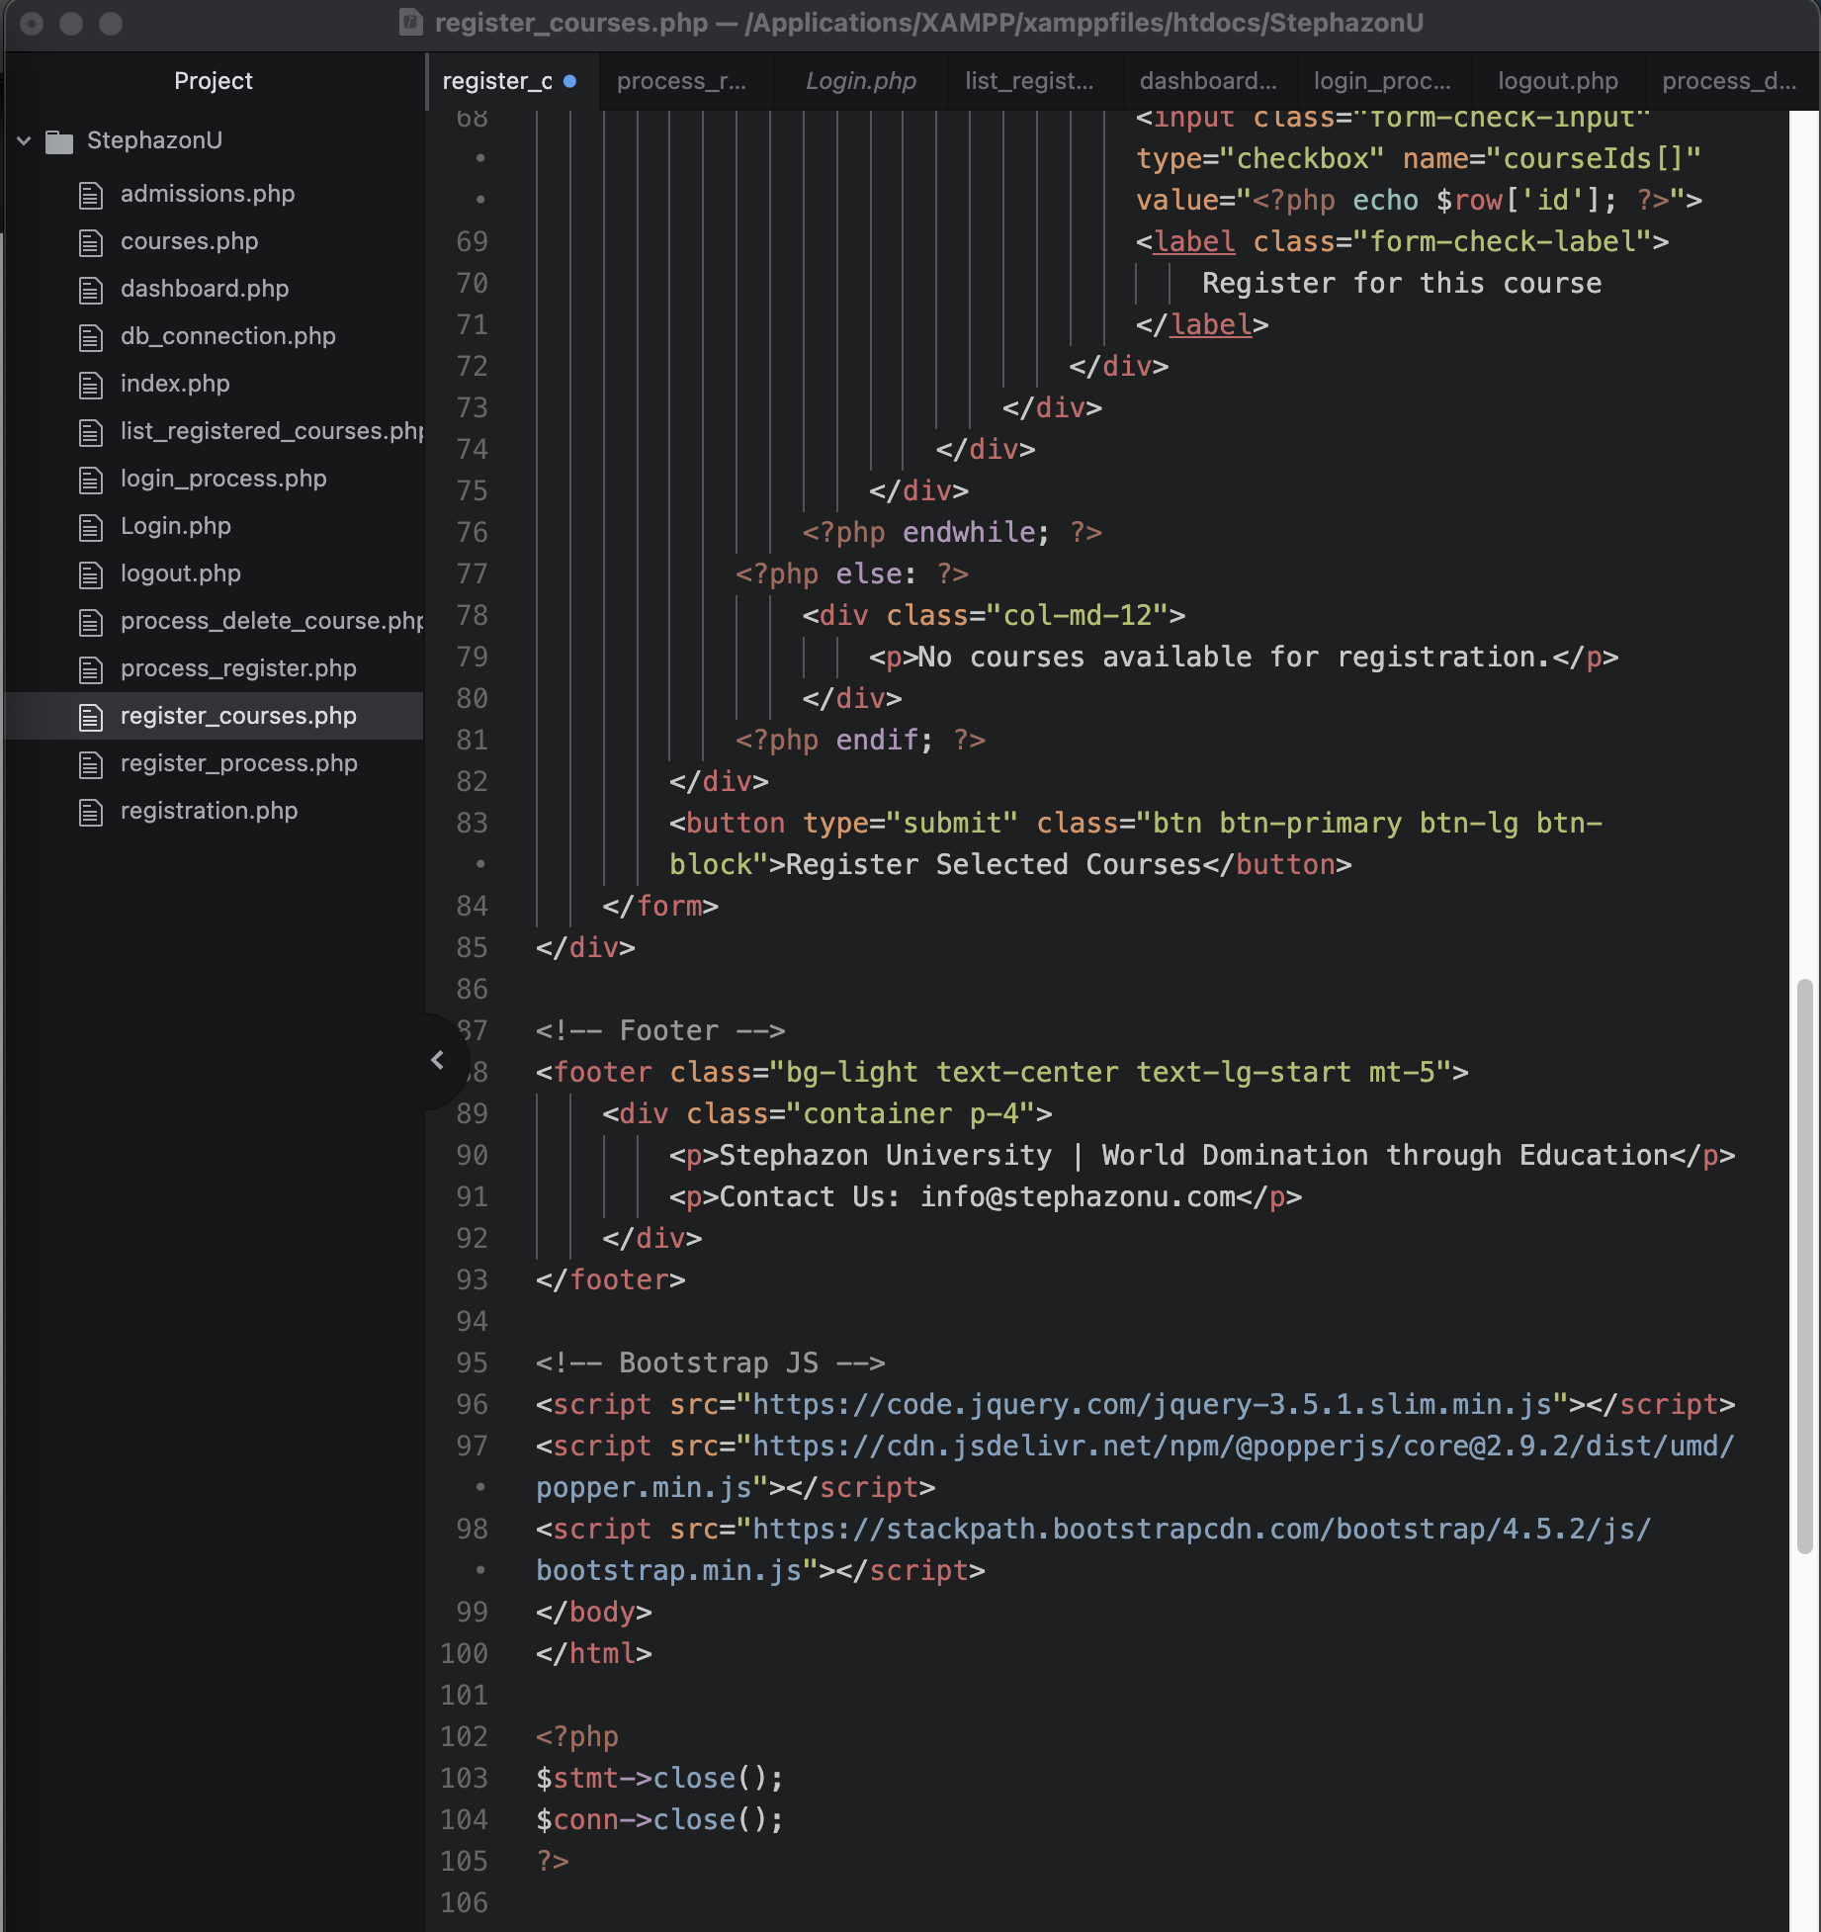
* **Dashboard Logic (dashboard.php)**
* 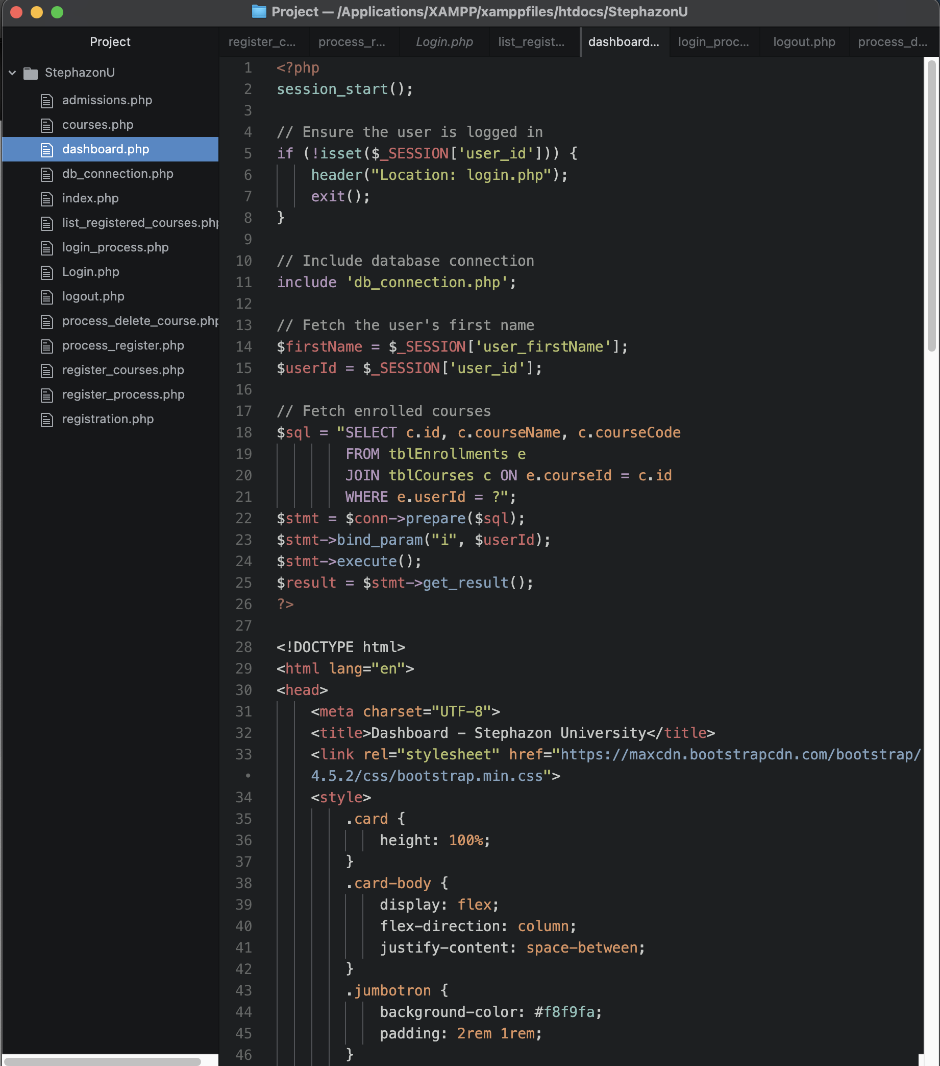
* 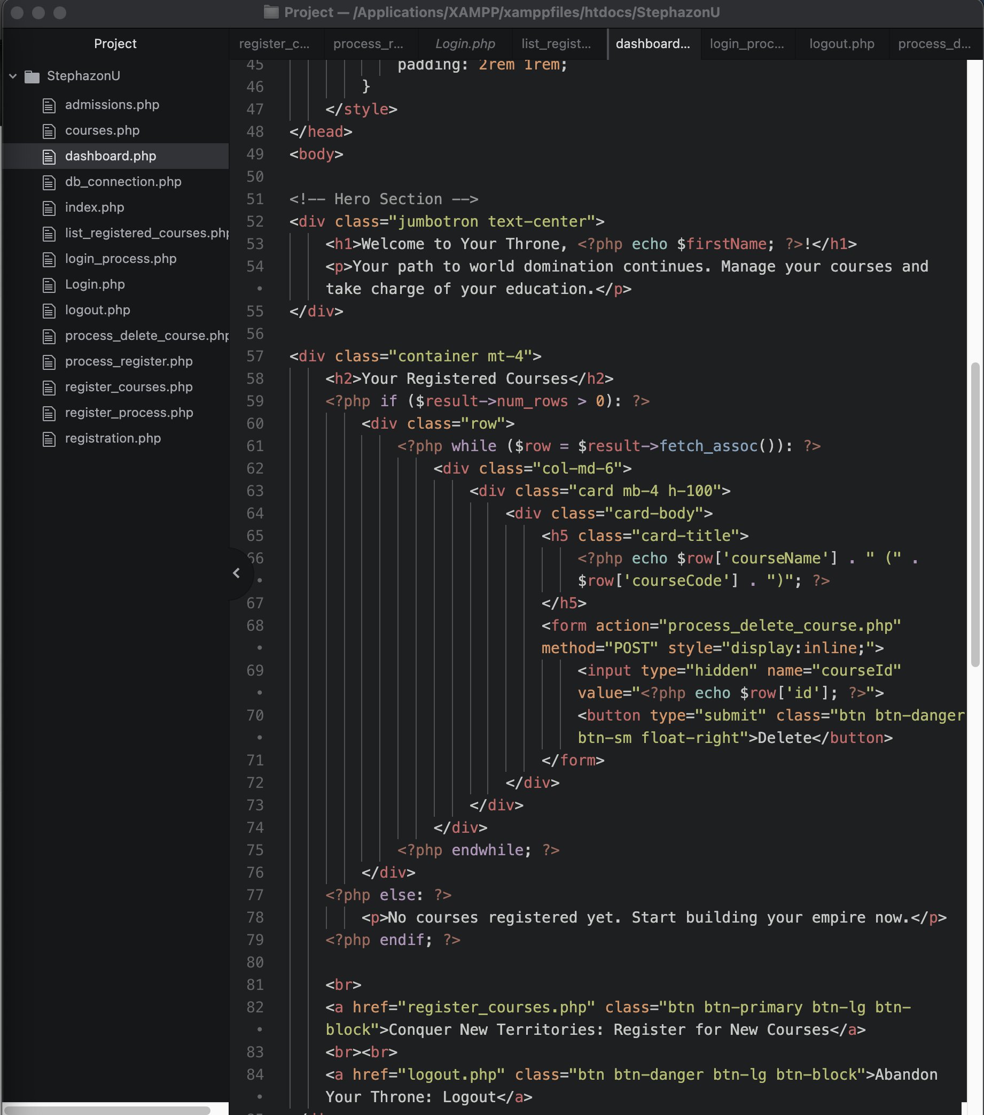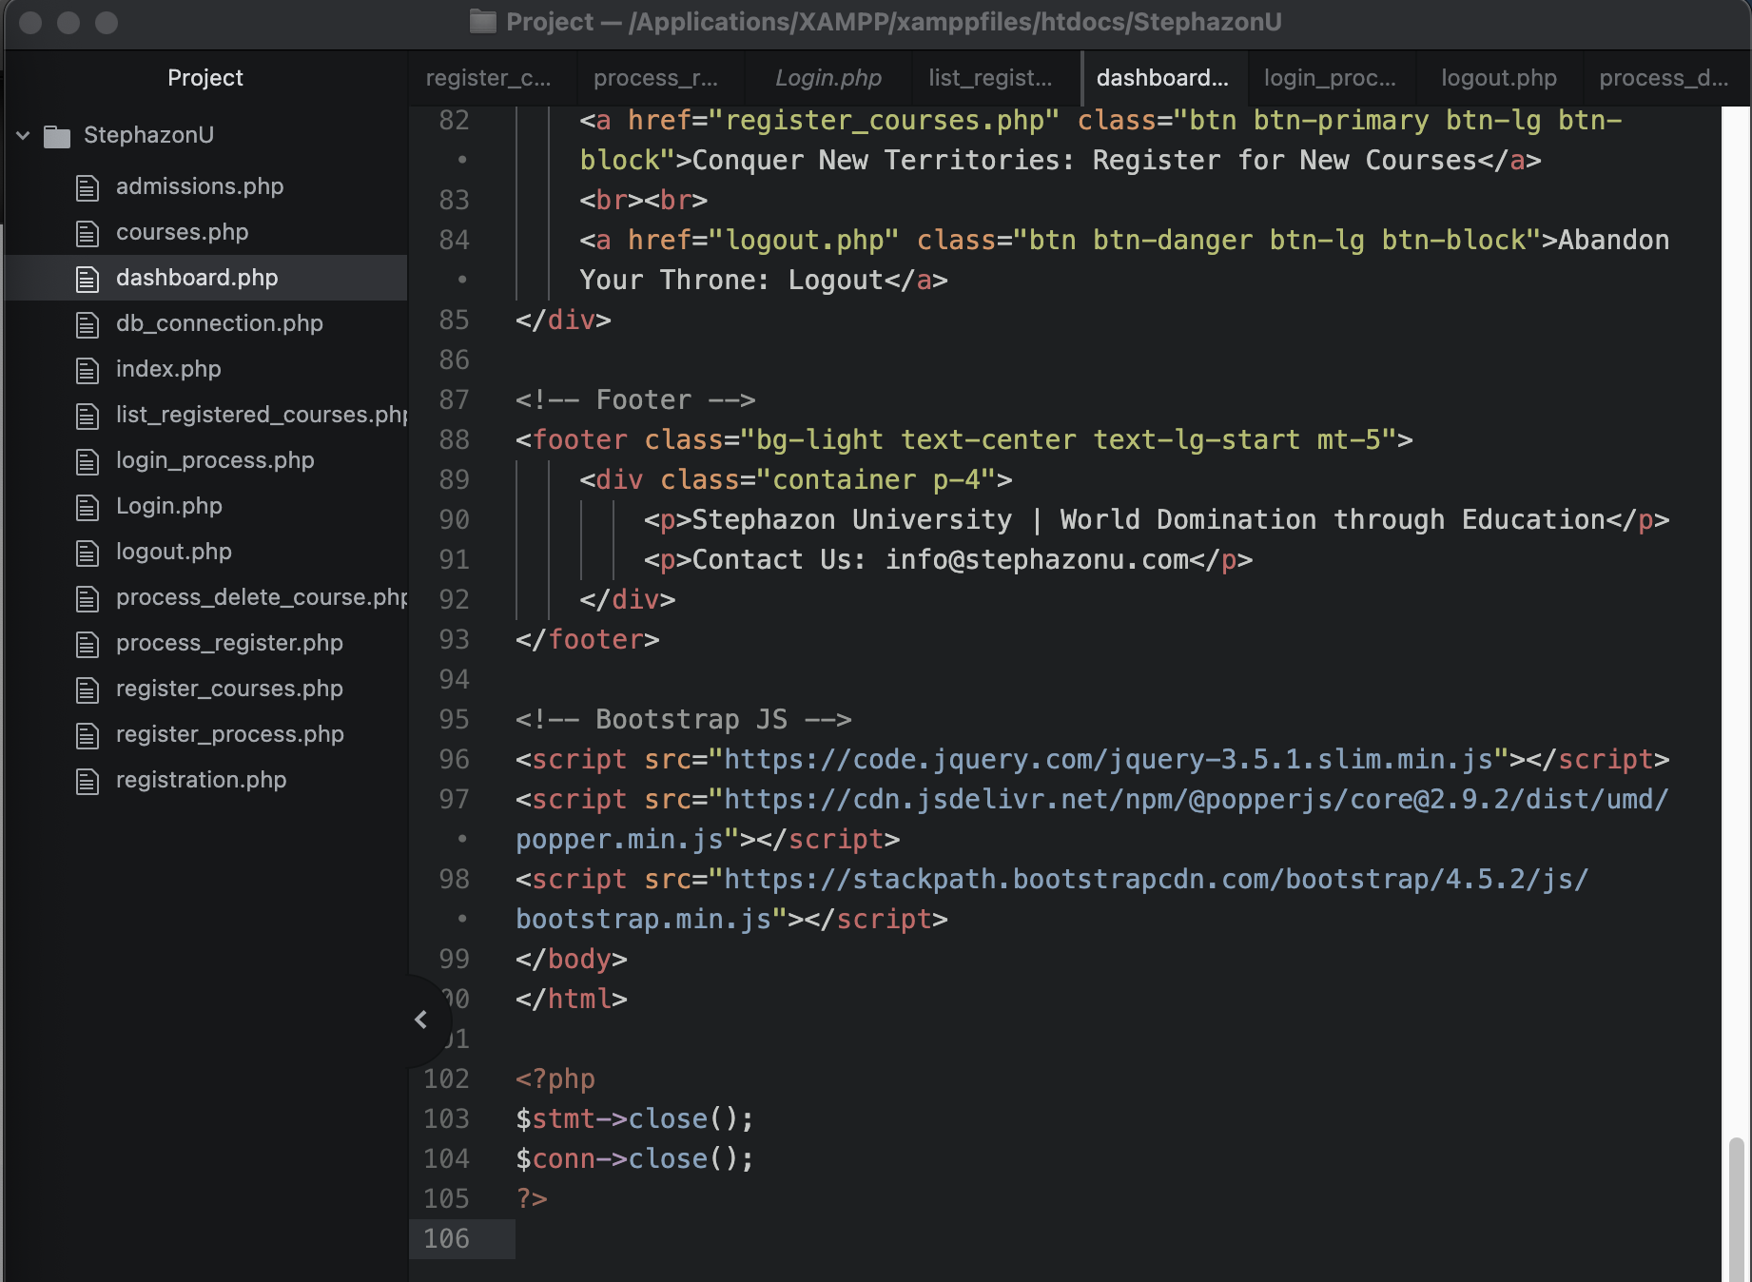
* **Delete Course Logic (process_delete_course.php)**
* 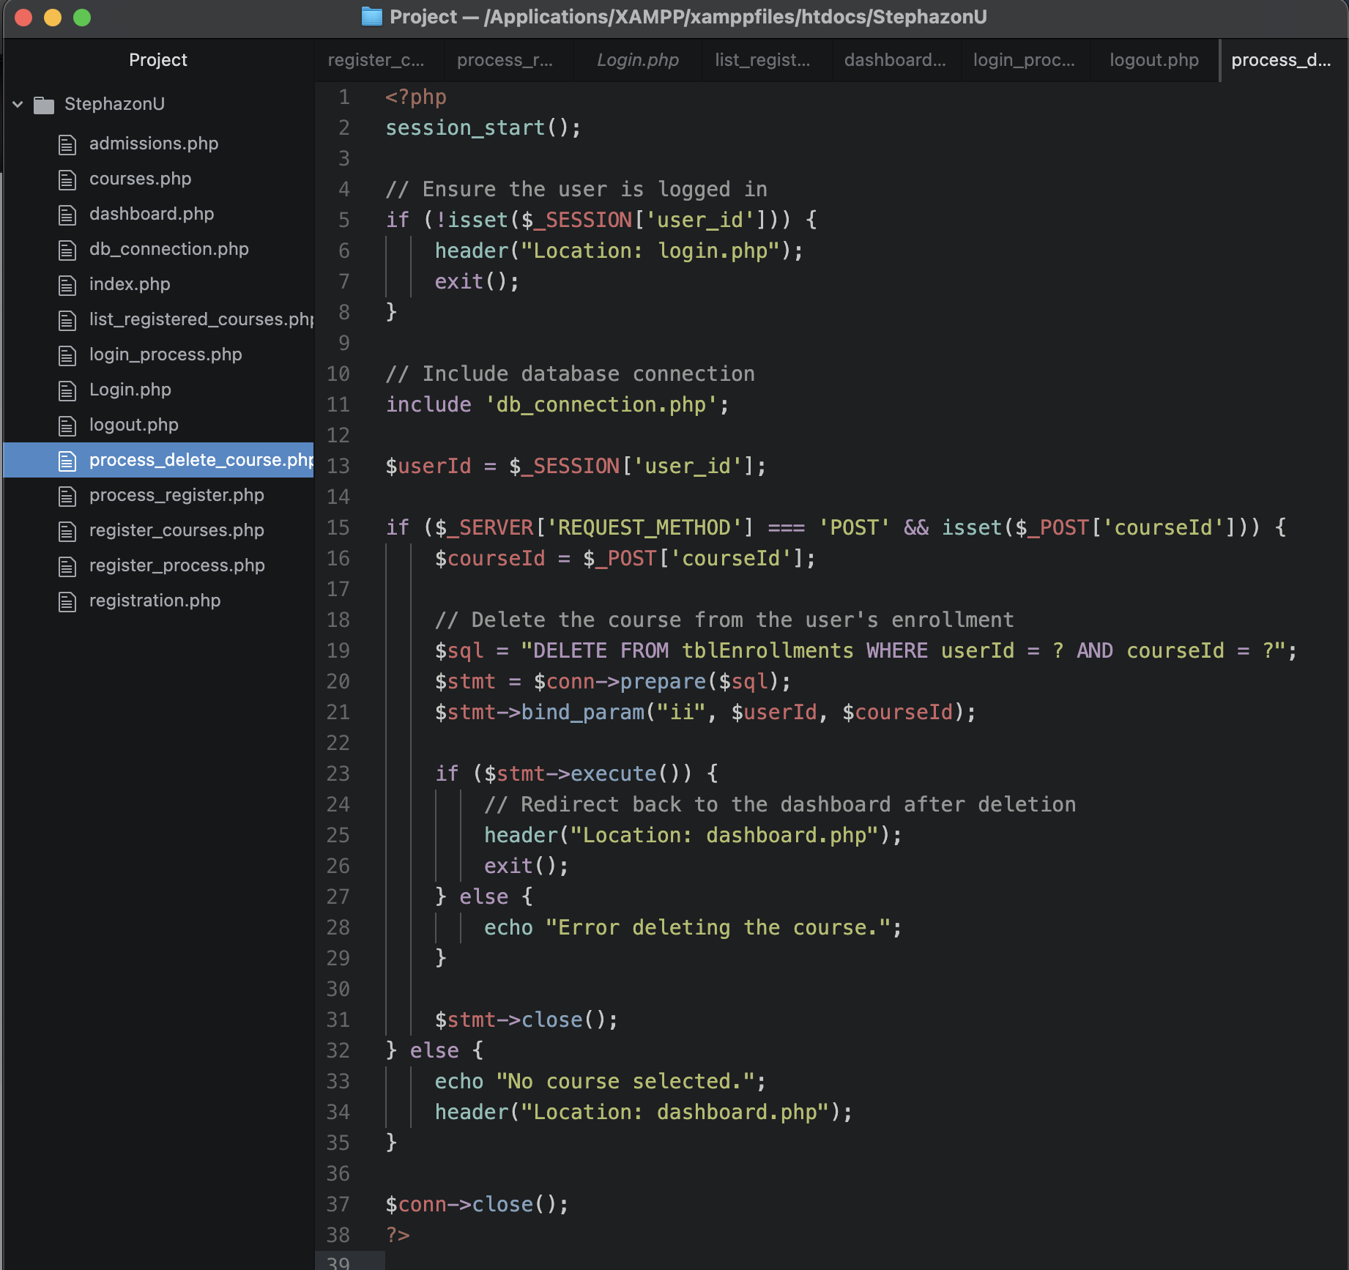

**2. Implementing Phase Summary**

Implementing this project was both rewarding and insightful. As I now understand PHP, HTML, and SQL much better, I enjoyed experimenting and building out the solution. One key approach I adopted this time around in contrast to my first web page implementation in my previous course, was separating PHP and HTML into different files for ease of editing and maintainability. This allowed me to organize my code just a bit better, which is something I found particularly useful as the project grew in complexity.

Debugging was one of the more challenging aspects of this project, and I made sure to incorporate testing as I progressed. Using a black box testing approach, I focused on the behavior and output of the system rather than diving into the underlying code right away. As “The first step of web app testing is performed through stress testing which ensures that the functions of a system are tested” (Vogels, 2024). For instance, I tested the functionalities by logging in as different users and registering for courses, then checking the database to ensure the data was properly reflected. After enrolling, I verified the dashboard showed the correct registered courses for each user. Similarly, I tested adding more courses and confirmed they appeared on the dashboard. For the delete functionality, I selected courses for removal and checked both the dashboard and the database to ensure the changes were accurately processed. I encountered issues with the delete button on the dashboard not correctly removing the selected course. Although I initially struggled with ensuring that the correct courseId was passed from the HTML form to the PHP script, repeated testing helped me identify the issue.

Through this process, I realized I had missed key points where I should have validated and handled data before passing it to the database. By focusing on how the system responded to inputs and outputs, I refined the delete functionality and improved data validation, ensuring reliable performance.

Eventually, with trial and error, I figured out the nuances of handling user input securely, making sure the courses could be registered, listed, added, and deleted correctly. This process was definitely an eye-opener and further solidified my understanding of integrating PHP, HTML, and SQL in a well-structured way.

**Summary of Implemented Functionalities:**

* **Creating MySQL Tables**: We structured the database by creating tables like tblUsers, tblCourses, and tblEnrollments.
* **Connecting Pages to the Backend Database**: Each page was connected to the backend using PHP’s MySQLi extension for secure data handling as it “helps us interact with the MySQL database using PHP” and “supports prepared statements that significantly enhance the security of database” (Aibin, 2024)
* **Registering for Classes**: Users can register for courses through the registration page, and the data is stored in the tblEnrollments table.
* **Listing Registered Classes**: The dashboard dynamically displays registered classes from the database.
* **Adding Courses**: Users can add more courses to their schedule, which updates the database and reflects on the dashboard.
* **Deleting Courses**: The delete functionality allows users to remove courses, but I initially struggled to get the selected course passed properly through the form, which I eventually resolved after debugging.

In the end, all these tasks helped strengthen my development skills and gave me a deeper understanding of building robust, user-focused web applications

**References:**

Aibin, M. by: (Ed.). (2024, March 18). *Enable the mysqli extension on linux*. Baeldung on Linux. https://www.baeldung.com/linux/mysqli-extension-activate

Vogels, R. (2024, September 20). *Web application testing: 6-step guide how to test a website*. Usersnap Blog. <https://usersnap.com/blog/web-application-testing/>

Tsui, F., Karam, O., & Bernal, B. (2018). [*Essentials of software engineering*](https://uagc.instructure.com/courses/137118/modules/items/6984922)(4th ed.). Jones & Bartlett Learning.